BANANA PROBLEM

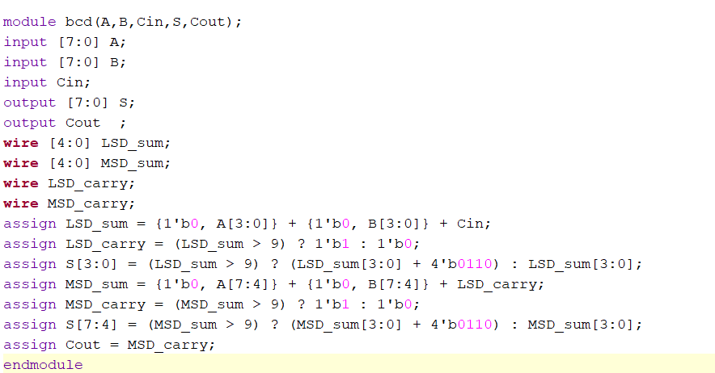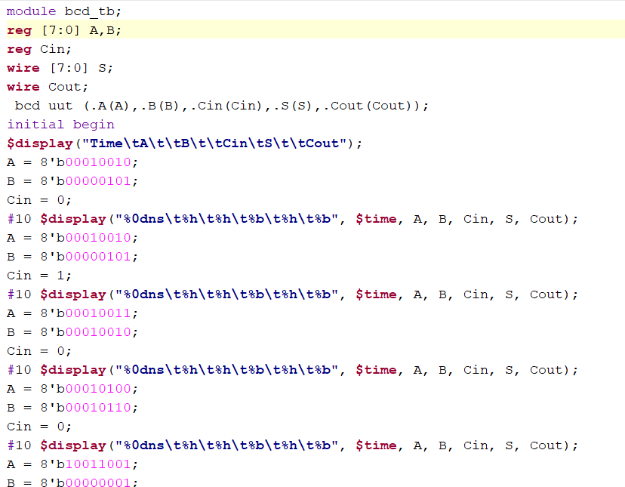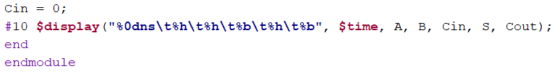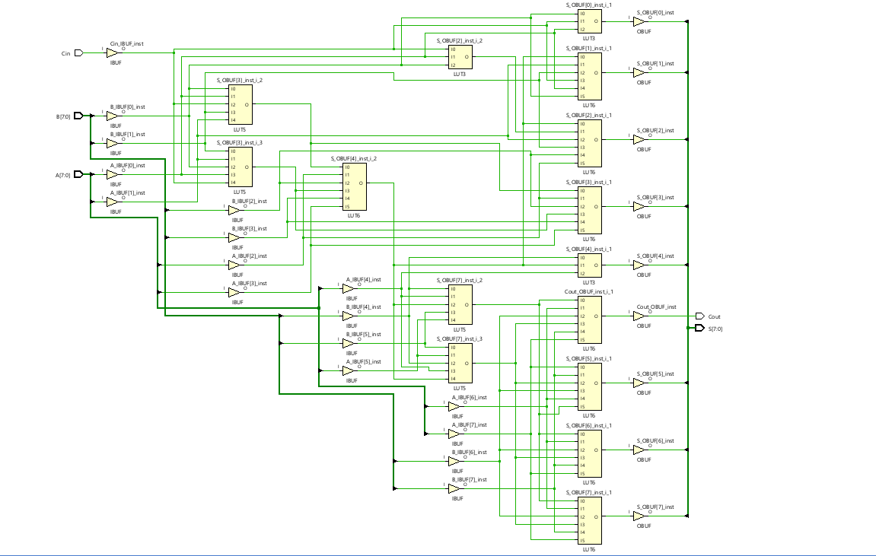

ORANGE PROBLEMS

1. 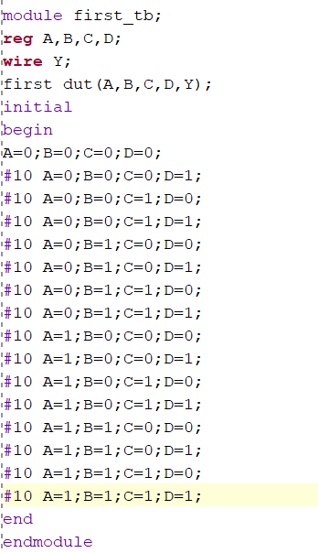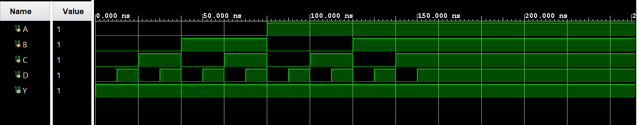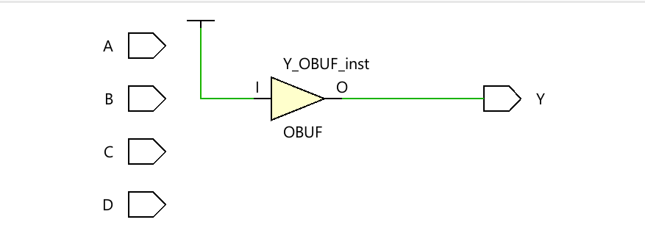
2. 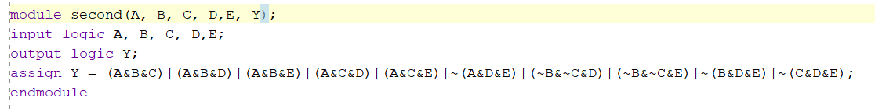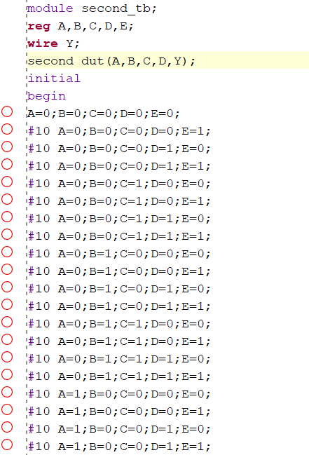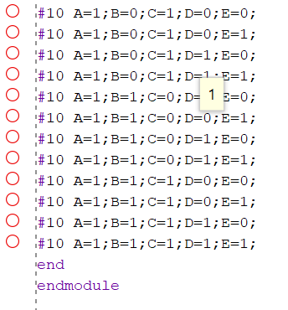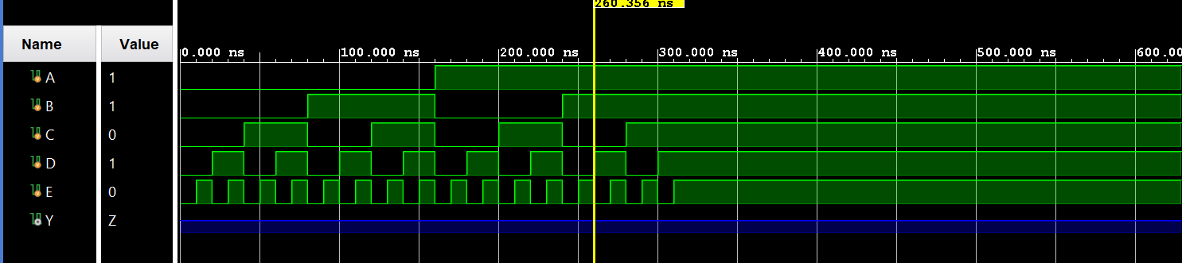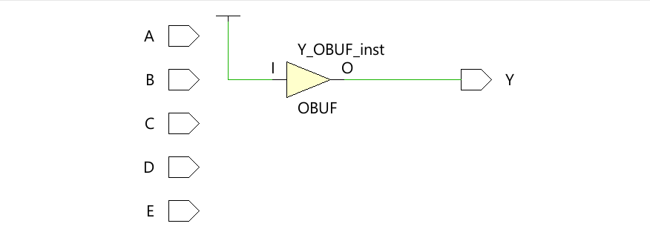

c.

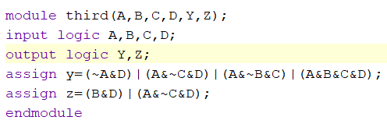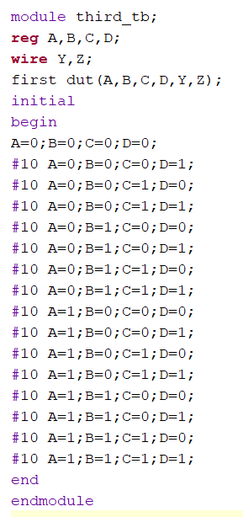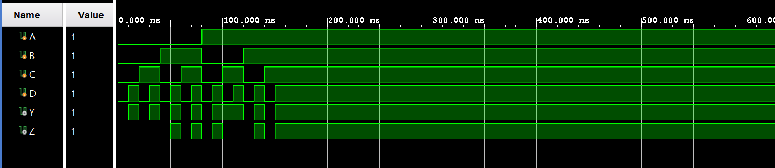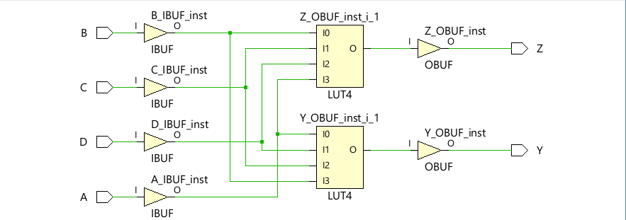

d.

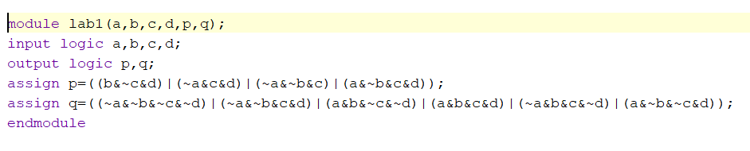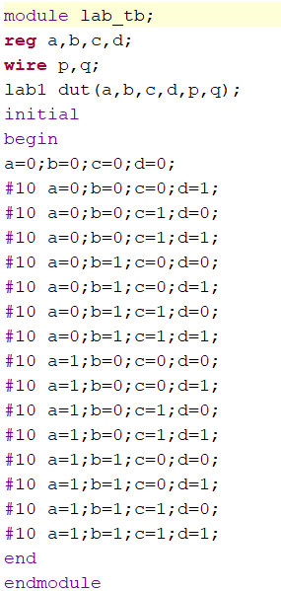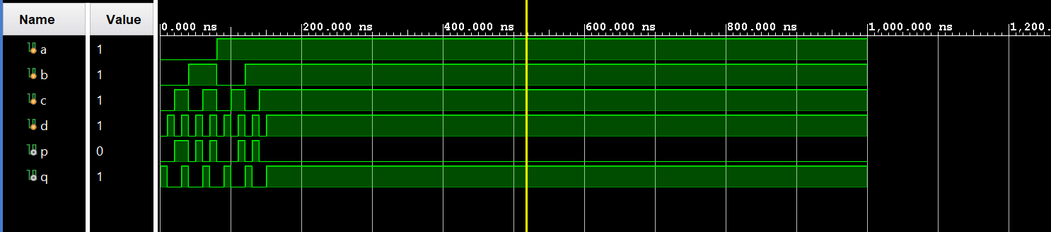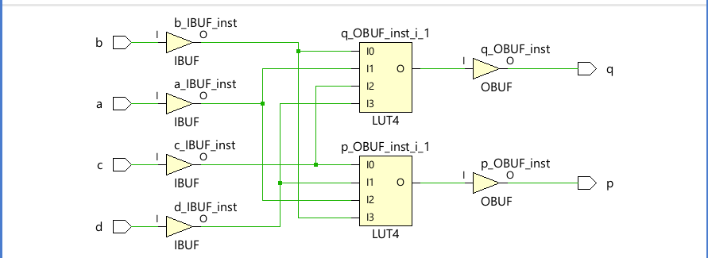

e.

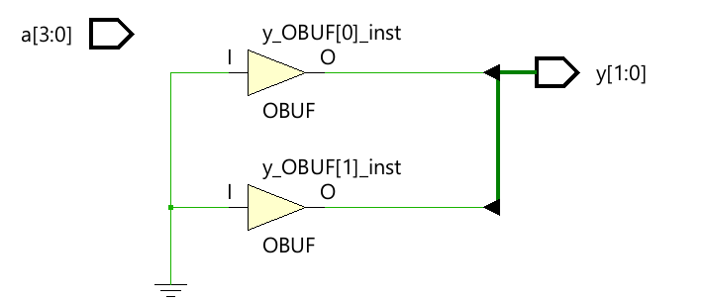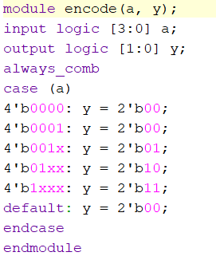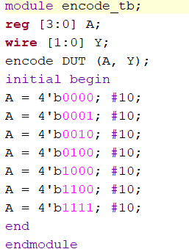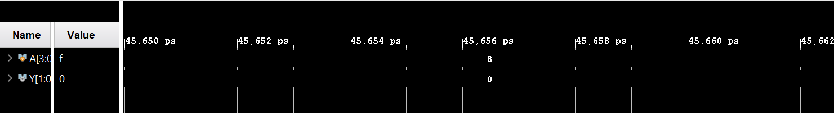

f.

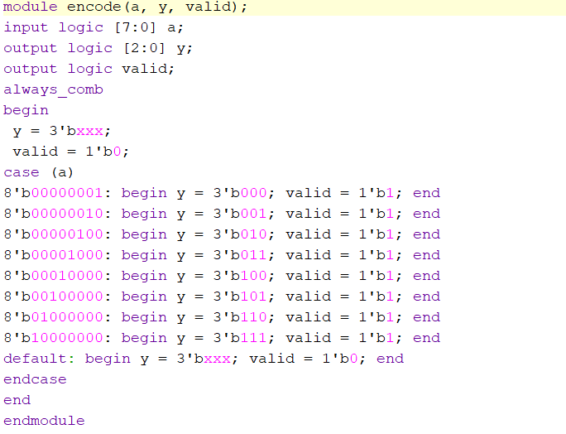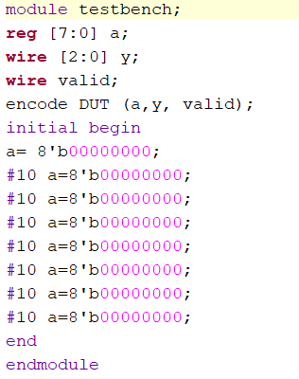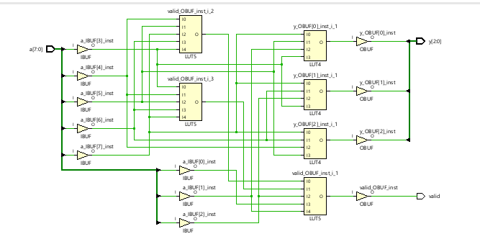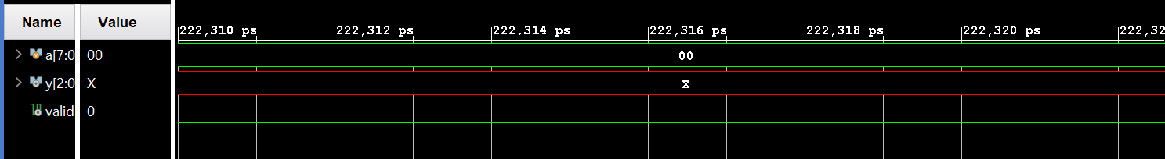

g.

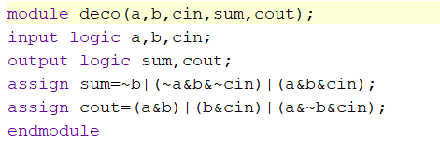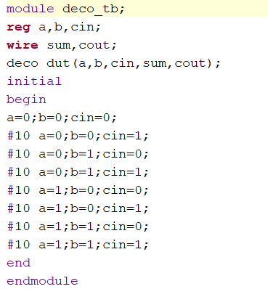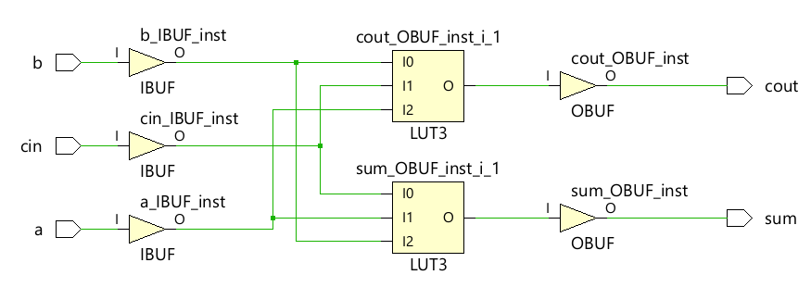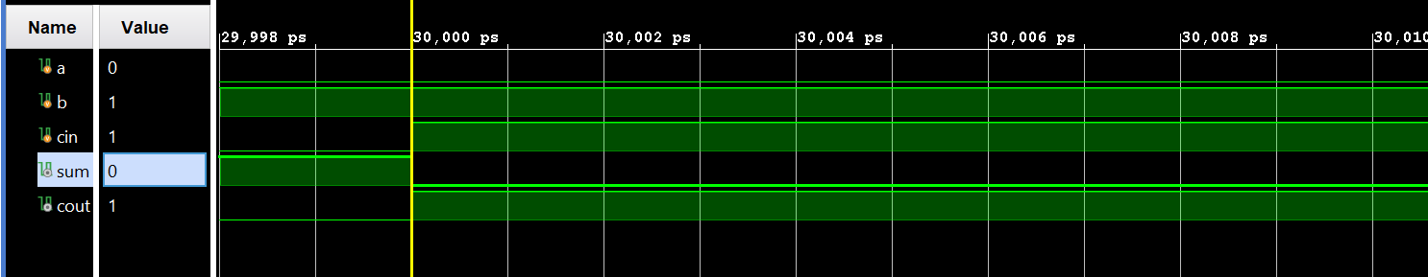

i. 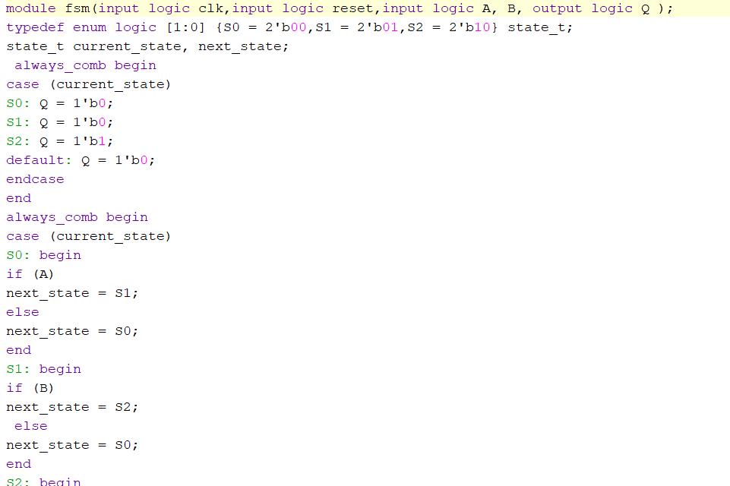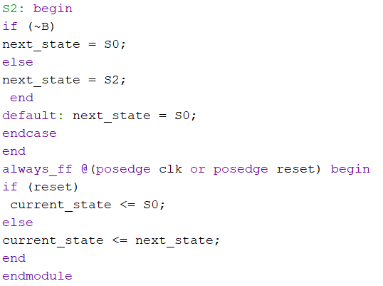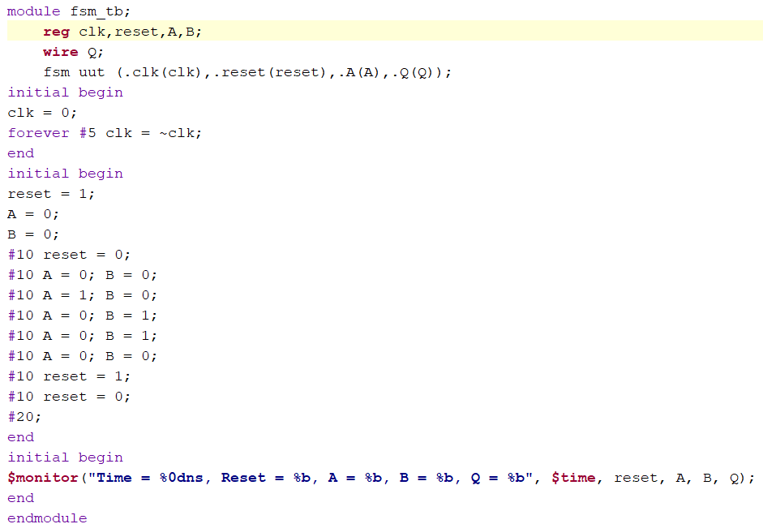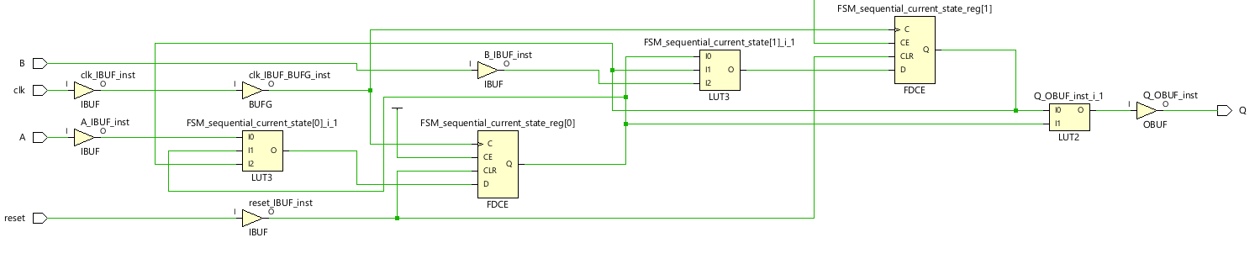

j.

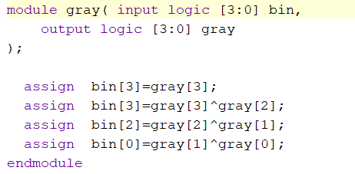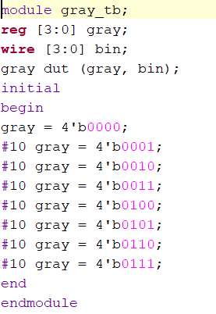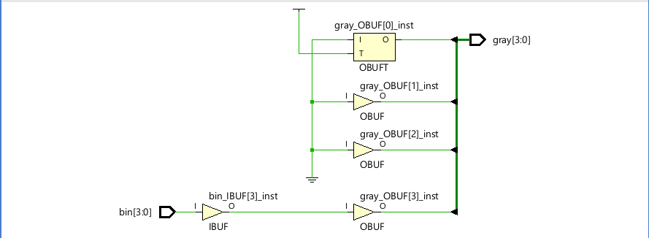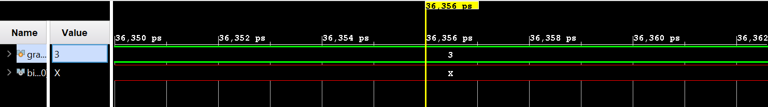

JACKFRUIT PROBLEM

FLOATING POINT MULTIPLIER

Floating Point Multiplier

1. Floating Point Multiplier

(a) Steps for 32-bit Floating Point Multiplication Extract Fields: Extract the sign, exponent, and mantissa from both 32-bit floating-point inputs. Sign Calculation: XOR the sign bits of the two inputs to get the sign of the result. Exponent Calculation: Add the exponents of the two inputs and subtract the bias (127 for single precision). Mantissa Calculation: Multiply the mantissas of the two inputs. Normalize the result if necessary. Normalization: Adjust the exponent and mantissa to ensure the mantissa is in the correct range. Rounding: Apply round toward zero (truncate). Assemble Result: Combine the sign, exponent, and mantissa to form the final 32-bit floating-point result.

Input A (Sign | Exponent | Mantissa) -> Input B (Sign | Exponent | Mantissa) -> Sign Calculation -> Exponent Addition -> Mantissa Multiplication -> Normalization -> Rounding -> Assemble Result

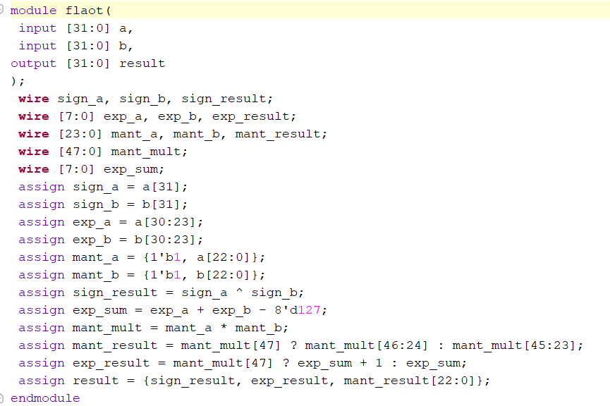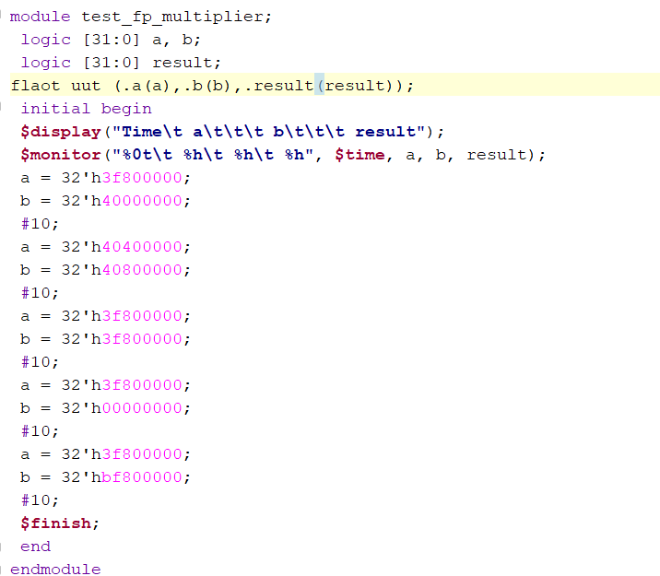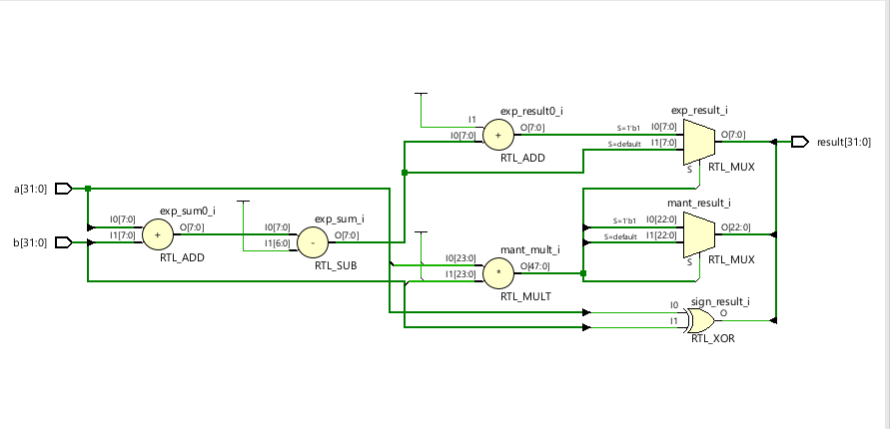

b.32 bit prefix adder

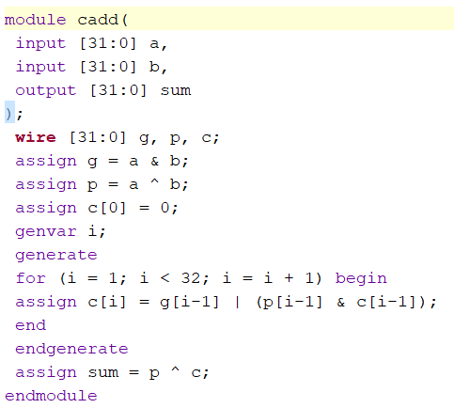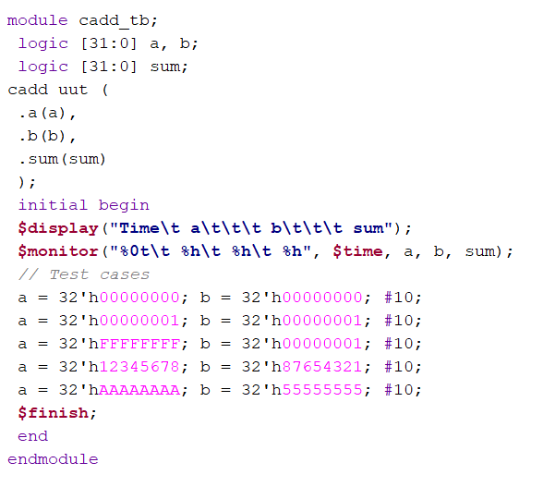

The delay of the 32-bit prefix adder can be calculated based on the number of stages in the prefix tree. Assuming each two-input gate delay is 100 ps, the delay can be estimated by counting the number of stages

